Arts Education CEATE Awardee Workshop (Secondary)
Creative Thinking Teaching Strategy
Lesson Design

Background information –
Project title | Theme exploration is a journey
Teacher | Fok Choi Yee Joyce
School | St. Paul’s Convent School
Target group | DSE Art (1st year of SBA research workbook building)

3 Problems | Constraints in terms of classroom environment and Limited life experiences | Environment and experience are proved to be very crucial for nurturing creativity. However, students are always limited to the same classroom environment, thus limiting their exposure to sources of inspirations and diversity of visual materials. Limited life experiences also limit their scope of thinking and abilities to see from different perspectives.
3 Problems | Unfamiliar themes | Students sometimes choose themes that they fancy or simply “like” it personally, but may not know deeply. It results in a research that is narrow, and thus a limited and superficial journey of theme exploration.
3 Problems | Hesitate in doing experiments | Students hesitate in doing quick and effective experiments. They only feel comfortable doing it when they can think of a “better” or even finalized idea. However, portfolio is to record the journey of idea development. Without proper documentation and experimentation, the process of thinking is not evident and shown.

3 Questions | How to guide the journey of theme exploration and portfolio building which is stimulating, open and at the same time relevant?
3 Questions | How to help students explore themes with broader research basis?
3 Questions | How to get students start doing experimentation quickly and effectively?

3 Solutions | Site Investigation (Experience)
3 Solutions | Unexpected Associations (Associate)
3 Solutions | Rapid Prototyping (Visualise)

Creative tools -
IDEO card | Look | Guided Tours | Accompany participants on a guided tour of the project-relevant spaces and activities they experience | Creative Tools | P.74 | Mindmapping
 |  |  |  |  | P.94 | Culture and Creativity
IDEO card | Look | Still-Photo Survey | Follow a planned shooting script and capture pictures of specific objects, activities, etc. | Creative Tools | P.122 | Collecting
IDEO card | Ask | Surveys and Questionnaires | Ask a series of targeted questions in order to ascertain particular characteristics and perception of users. | Creative Tools | P.20 | Empathising
IDEO card | Ask | Unfocus Group | Assemble a diverse group of individuals in a workshop to use a stimulating range of materials and create things that are relevant to your project | Creative Tools | P.12 | Break the Rules
IDEO card | Try | Paper Prototyping | Rapidly sketch, layout and evaluate interaction design concepts for basic usability. | Creative Tools | P.104 | 3D Thinking
IDEO card | Try | Quick-and-Dirty Prototyping | Using any materials available, quickly assemble possible forms or interactions for evaluation. | Creative Tools | P.112 | Experiencing Products

References -

IDEO card
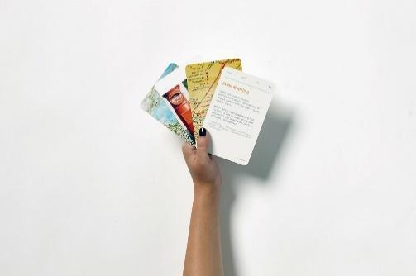 https://www.ideo.com/post/method-cards
Creative Tools
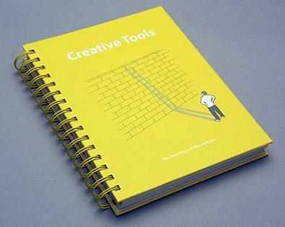 Creative tools by Alex Archer, Fung | Editor: School of Design, Hong Kong Polytechnic University

Teaching strategies and activities -
IDEO card |  | Creative Tools | Teaching Activities
Guided Tours |  | Mindmapping | Site Investigation  (Observation and Recording) | Students start their project through investigating on a chosen site. They can either choose a location randomly or based on their assumptions on what they can see after having their initial ideas.  Teacher/student plan a route for the visit based on their initial impression and research on the site.  The first tour is to give students a general picture of the site do observation and recording, and find out things that catch their attention. After the visit, students will create a visual mindmap with a key image at the centre that he or she found most inspiring or special. Visual mind map helps them to organise ideas and at the same time create associations to areas which are not expected at first.  After the first visit, students should have narrowed down their interests, and started doing background research on related issues/aspects.  The second visit is a more planned one with set tasks, e.g. photo survey, survey and questionnaire for collection more relevant information. Students should plan for a still-photo survey/sketch to capture specific objects, human activities, architecture, etc. During the trip students can collect items which are relevant and inspiring for recording.
Guided Tours |  | Culture and Creativity | Site Investigation  (Observation and Recording)
Still-Photo Survey |  | Collecting | Site Investigation  (Observation and Recording)
Surveys and Questionnaires |  | Empathising | Site Investigation  (Observation and Recording)
Unfocus Group |  | Break the Rules | Unexpected Associations  (Connect) | Students have experienced different things or have observed different activities during the guided tour.  Assemble a diverse group of individuals in a workshop to use a stimulating range of materials and create 2D and 3D experimental outcomes that are relevant to their project.  During the workshop students are encouraged to make use of forced connection so as to create unexpected and inspiring results. This is an in-class short task, and students will present their ideas to justify their work.
Unfocus Group |  | Forced connection** | Unexpected Associations  (Connect)
Paper Prototyping |  | 3D Thinking | Rapid Prototyping  (Empathise and Visualise) | Students find out “problems” or “issues” that they have found in the site.  With the help of teachers, students draft design briefs for their projects. After doing further research, idea development and experimentation, students are encouraged to create pilot projects through rapid 3D sketching and prototyping.  Students can invite users to experience the design outcomes. Surveys and questionnaires can be designed to review the user experience.
Quick-and-Dirty Prototyping |  | Experiencing Products | Rapid Prototyping  (Empathise and Visualise)
Quick-and-Dirty Prototyping |  | Empathising | Rapid Prototyping  (Empathise and Visualise)

**Lesson Plan –
Title | Explore new possibilities through the use of creative tools
Duration | Approx. 1 hour 30 mins
Objective | - Explore more unexpected possibilities for idea generation  - Develop ideas and sketches on paper into 3D objects through rapid prototyping for idea development  - Evaluate and refine prototypes  - Collect others’ ideas and perspectives and evaluate own ideas and prototypes
Outcome | Ideas in the form of sketches and quick prototypes contributed by others
Class | Form 5 DSE Visual Arts (1st year of DSE)
Class size | Small class

Rundown | Duration
Welcome all;  Introduction of lesson objectives | 5 mins
Introduction of forced connection* as a creative tool for idea generation | 10 mins
Activity I – Making Unexpected Associations  Task-  - Students have collected series of images and relevant subject matters* after site investigation  - Print out the images and relevant subject matters  - Each student in the group draw a card from “Forced Connection Cards”  Each card suggest different category, e.g.  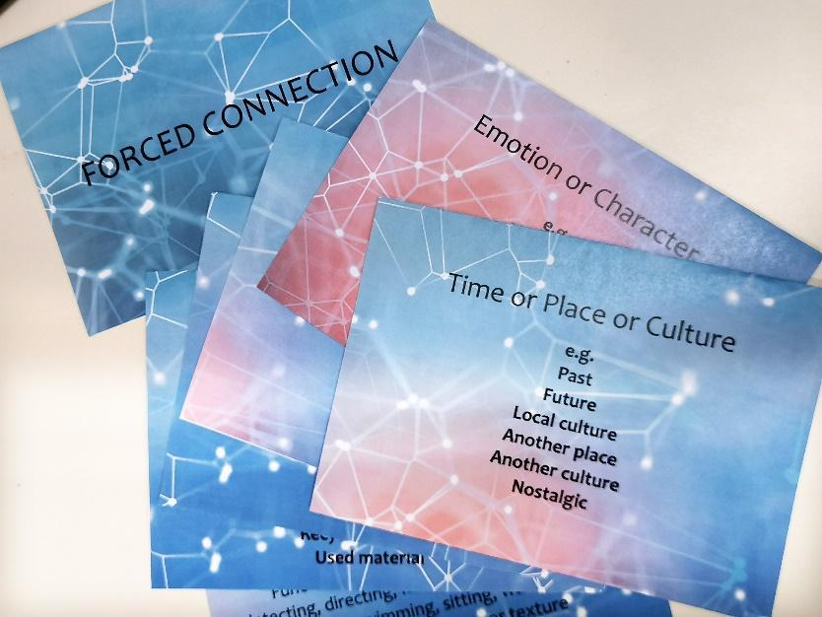  4. Pair up one chosen image/subject matter with the suggested feature on the card according to  the descriptions. Each card suggests different category, e.g.  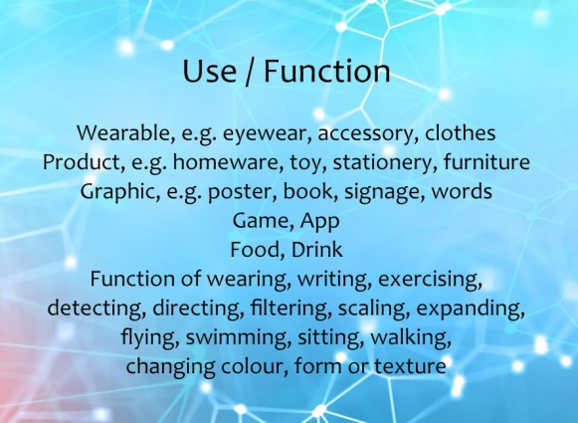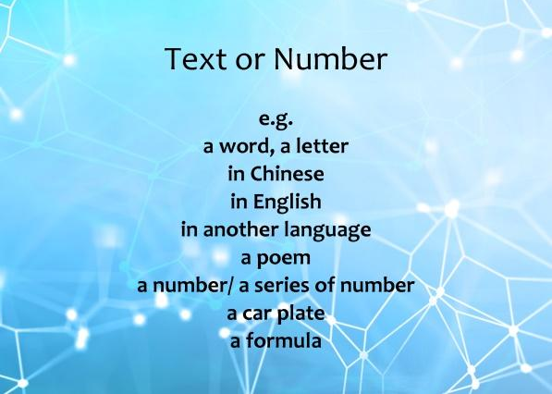  5. Come up with new possible combined experimental outcome  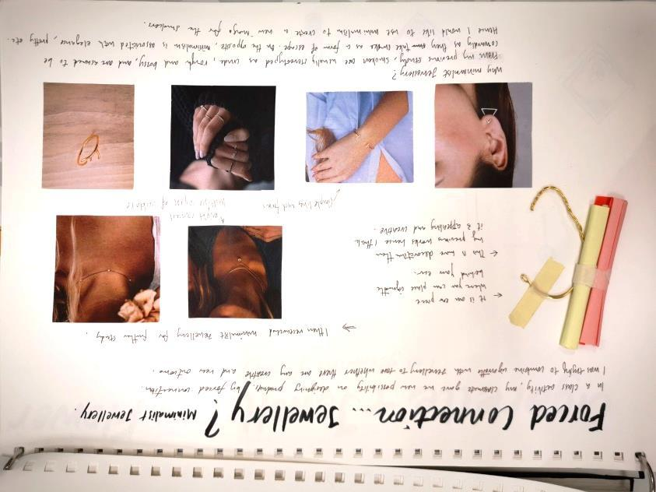 | 15 mins
Students share their ideas and outcomes  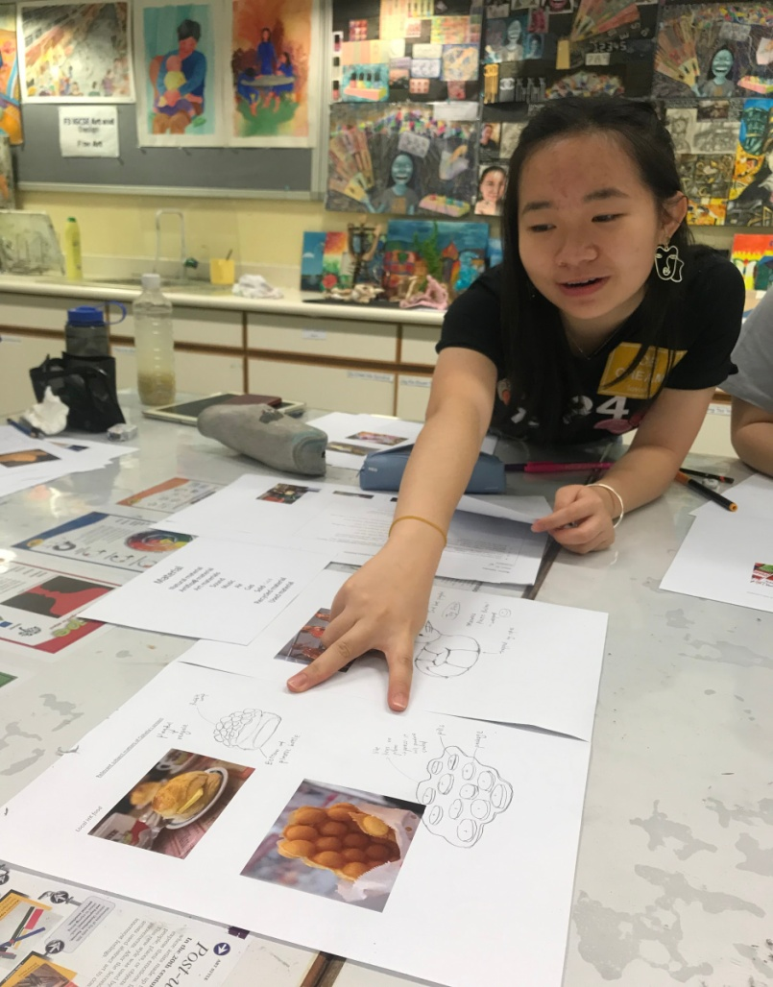 | 10 mins
Introduction of SCAMPER as creative approaches for reviewing ideas and prototypes of outcomes  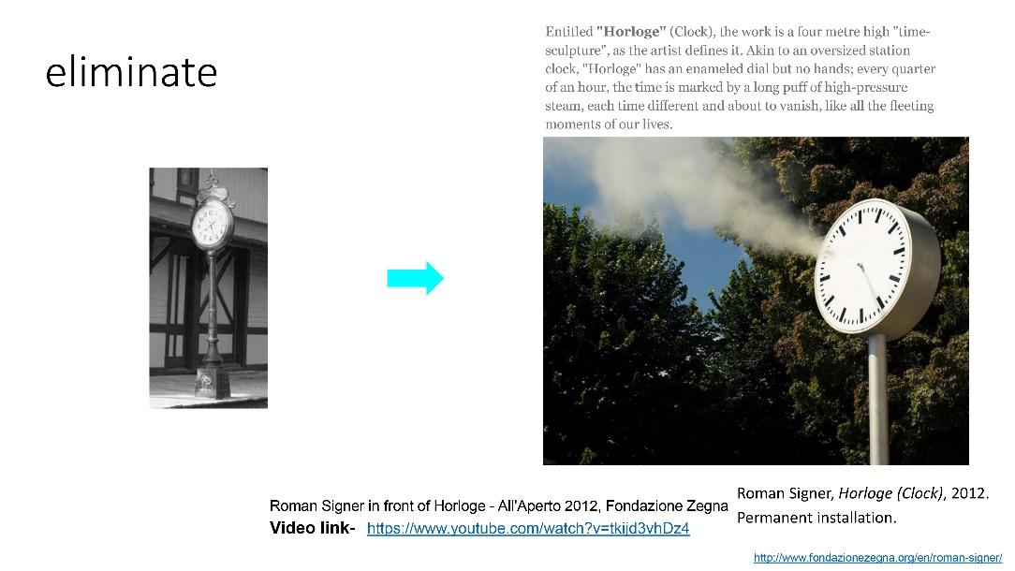  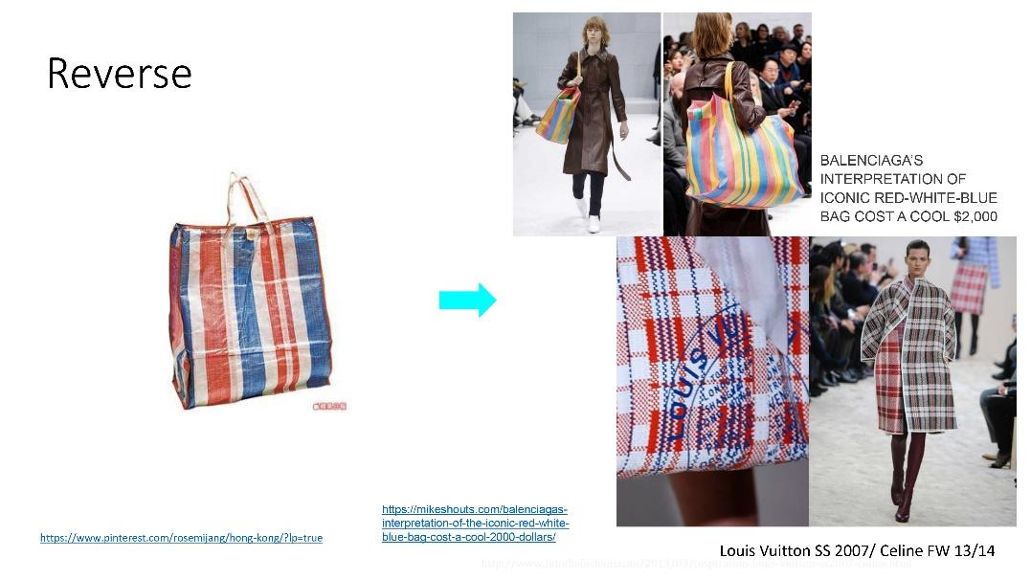 | 10 mins
Activity II – Use the “SCAMPER” approaches to create even more possibilities  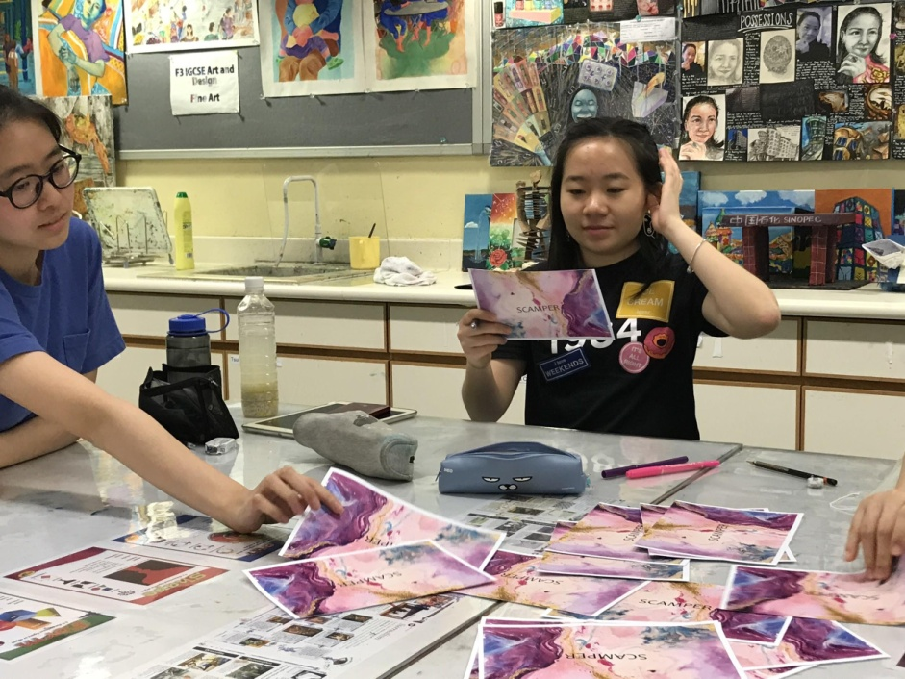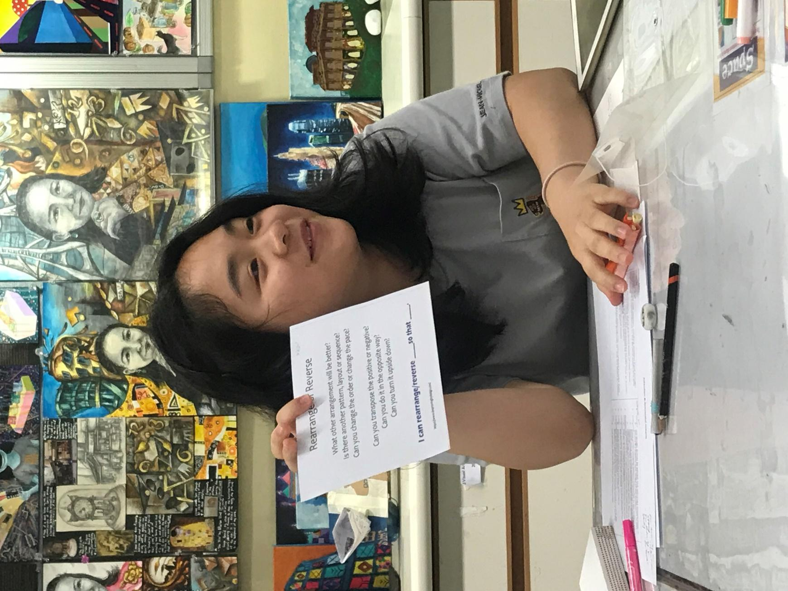 | 10 mins
Activity III – Quick Prototyping  Task-  Select 1 potential outcome and make a quick prototype of it for visualization  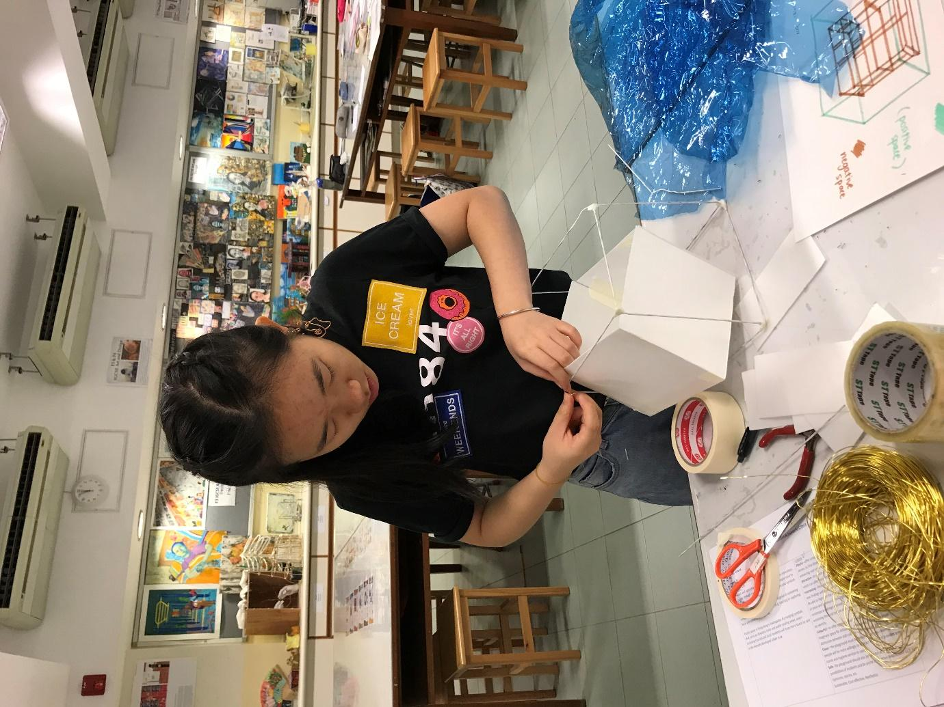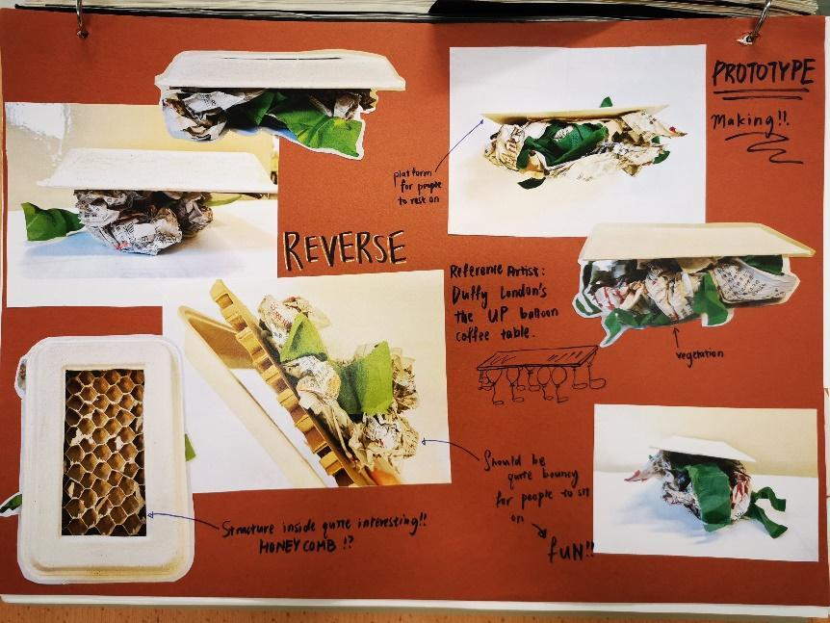 | 20 mins

Students share their ideas and outcomes | 10 mins
Record activity outcomes and evaluation on sketchbook (home assignment)  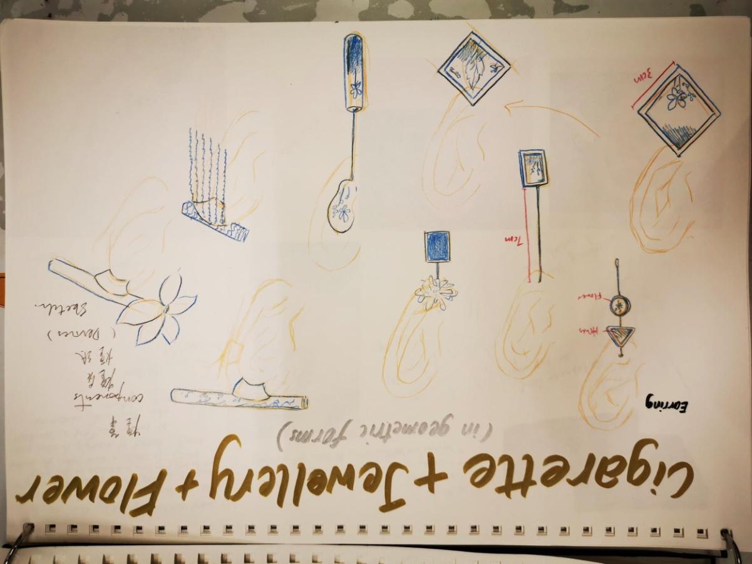 | --

Design thinking approaches and tools used -
IDEO card | - Quick and Dirty prototyping
Book: Creative tools | - Forced connection cards*  - 3D thinking approach
From CEATE AE group | - SCAMPER cards  - Evaluation chart

Evaluations -
 | Students | Teacher
 | - Improved observational skills  - Explored mores possibilities of themes  - Found new areas for further research  - Found more sources of visual materials  - Created more experimental visual outcomes during the journey  - Created more unexpected outcomes  - Came up with themes which are not expected and based on my own experiences and observations  - Generated more ideas  - Inspired by classmates who gave me suggestions on my own projects during the forced connection and scamper activities | - Were to provide more guidance to students for the selection and organisation of materials from the vast amount of collected materials,eg. mind mapping  - Were to study the issues that the students concern and make suggestions for filling in the gaps in the research  - Were satisfied with the visual outcomes produced by students documenting the development of theme exploration
- Had to see if the ideas suggested by others are relevant to my project (delivering my intentions)
- Had to do quite a lot of research for filling up the gaps especially for the new areas which I do not know about
- produced extra visual outcomes which may not be further developed as they were not relevant to my intentions

