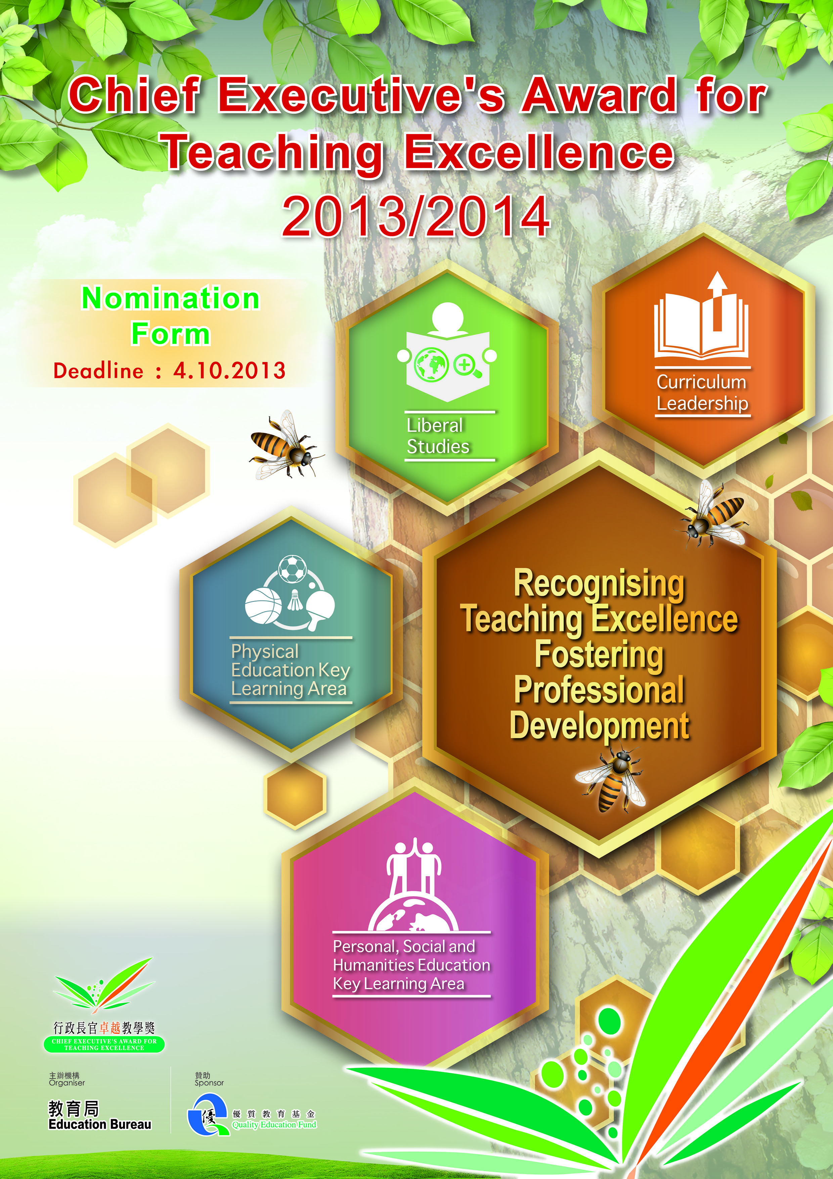

Chief Executive's Award for Teaching Excellence (2013 / 2014)

Nomination Form

Please read the Nomination Guidelines carefully before filling in the Nomination Form.

This Nomination Form comprises four sections:

Section I - To be completed by the Nominee1
Part A: Particulars of the Nominee
Part B: Nominee's / Group's Description

Section II - To be completed by the Nominator
Part A: Particulars of the Nominator
Part B: Reason(s) for Making the Nomination

Section III - To be completed by the Seconders
Part A: Particulars of the Seconder
Part B: Comments of the Seconder (Optional)

Section IV - Collection and Use of Personal Data

Enquiries
If you have any enquiries, you are most welcome to contact the CEATE Secretariat through the following ways:

By Tel. : 2892 5782
By E-mail : ate@edb.gov.hk
By Post : The CEATE Secretariat, 11/F., Wu Chung House, 213 Queen’s Road East, Wan Chai, Hong Kong

1 In this Nomination Form, "Nominee" means the nominated teacher of an individual nomination or all group members of a group nomination.

1

Section I -
To be completed by the Nominee

Part A: Particulars of the Nominee

For group nominations, each Group should comprise not more than five teachers. Please make copies of Part A for each nominee to fill in.

- Name: Dr / Mr / Ms* (English)

(Chinese)

- HKID No. (Letter(s) + first 4 digits): (e.g. A 1234)

- Years of Teaching in HK:

- Teacher Registration No.:
(Teachers who are exempted under Section (9)(1)(a) of the Education Ordinance, Cap 279 are not required to fill in this item.)

- Subject(s) taught in the past 3 years:
(Kindergarten2 teachers are not required to fill in this item.)

- Involved in Curriculum Leadership in the past 3 years: Yes / No*

- Name of School:
(Kindergarten2 / primary school/ secondary school/ special school)*

- Theme to which your nomination belongs:

Curriculum Leadership/ Liberal Studies/ Personal, Social and Humanities Education KLA/ Physical Education KLA *

- School Address:

- Tel. No.: (School) (Mobile)

- Fax. No.:

- E-mail:

- Delete where appropriate.
- Including kindergarten-cum-child care centres and schools with kindergarten classes. 2

Section I -
To be completed by the Nominee

- Education-related working experience in Hong Kong

Organisation
Post
Period of Service

___________________

___________________

___________________

___________________

- Education-related Professional Qualifications

Awarding Institution
Qualification Obtained
Conferment Date

___________________

___________________

___________________

___________________

- Education bodies/ organisations of which you were/ are a participant/ member

Body / Organisation
Position held
Period

___________________

___________________

___________________

___________________

- Name of the group leader (for group nominations only):

3

Section I -
To be completed by the Nominee

Part B: Nominee's/ Group's Description

- Nominees are required to describe the following in not more than 15 pages in accordance with the format as set out in paragraph 7.3 of the Nomination Guidelines:

  - A reflection of your teaching practices and your philosophy of teaching or conceptual framework on what constitutes excellence in Curriculum Leadership, Liberal Studies, Personal, Social and Humanities Education KLA or Physical Education KLA.

  - Relevant examples and details to illustrate the outcomes and effect in respect of the four domains of assessment as set out in paragraph 9.3 of the Nomination Guidelines.

  - What teaching practices you will disseminate and how you will take forward your dissemination, if awarded.

- Nominees may refer to the suggested questions as set out in the Appendix.

- Nominees could prepare their nomination documents in either Chinese or English.

- Nominees are kindly reminded that nominations which fail to comply with the requirements as stated in paragraph 7.2(b) and 7.3 of the Nomination Guidelines will not be considered.

- For group nominations, there is no need for each member to describe one's own reflection on teaching. The description should represent the reflection of the group as a whole.

- Nominees may be required by the Assessment Panel to submit more detailed information as evidence when necessary.

4

1

Section I -
To be completed by the Nominee

Declaration

- I hereby certify that the information contained in this Form is correct and true to the best of my knowledge.

- I agree to the rules and regulations as stipulated in this Form and the Nomination Guidelines and understand that my nomination will not be considered if it does not comply with the requirements as set out in paragraph 7.2(b) and 7.3 of the Nomination Guidelines.

- I am willing to participate in the sharing activities that may be organised by the Education Bureau or any other organisations/ agents authorised by the Education Bureau for the development of the teaching profession, should I be awarded.

- I agree that the Education Bureau may use, distribute, disseminate, publish and/ or reproduce the information related to the teaching practice(s) provided in or obtained from this nomination, should I be awarded.

Name(s) of Nominee(s)

1

2. _____________________

3. _____________________

4. _____________________

5. _____________________
Signature

______________________

______________________

______________________

______________________

______________________
Date

______________________

______________________

______________________

______________________

______________________

5

Section II -
To be completed by the Nominator

Part A: Particulars of the Nominator

Each nomination should be submitted by one Nominator only. Nominators should be school heads3, colleagues of the Nominee(s), peers or experienced educators in their personal capacity.

For self-nominations, please complete No. 1 only.

- Self-nomination: □ Yes □ No (please tick as appropriate)

- Name: Dr / Mr / Ms* (English)

(Chinese)

- Organisation:

- Position:

- Relationship with the Nominee(s):

- Professional Qualifications:

- Correspondence Address:

- Tel. No.:

- Fax. No.:

- E-mail:

- Delete where appropriate.

Part B: Reason(s) for Making the Nomination

Describe in not more than 500 words why you wish to nominate the Nominee(s). This part can be completed in either Chinese or English.

Signature of Nominator: Date:
- According to paragraph 6.6 of the Nomination Guidelines, the school heads of the nominees should either be the nominators or the seconders of the nominations. 6

Section III -
To be completed by the Seconders

Each nomination should be seconded by two to three Seconders who should be school heads, colleagues of the Nominee(s), peers, experienced educators, students (including past students) or parents in their personal capacity.

First Seconder

Part A: Particulars of the Seconder

  - Name: Dr / Mr / Ms* (English)

(Chinese)

  - Organisation:

  - Position:

  - Relationship with the Nominee(s):

  - Professional Qualifications in the Education Field (if applicable):

  - Correspondence Address:

  - Tel. No.:

  - Fax. No.:

  - E-mail:

* Delete where appropriate.

Part B: Comments of the Seconder (Optional)

Describe in not more than 300 words why the nomination is supported. This part may be completed in either Chinese or English.

Signature of First Seconder: Date:
7

Section III -
To be completed by the Seconders

Second Seconder

Part A: Particulars of the Seconder

- Name: Dr / Mr / Ms* (English)

(Chinese)

- Organisation:

- Position:

- Relationship with the Nominee(s):

- Professional Qualifications in the Education Field (if applicable):

- Correspondence Address:

- Tel. No.:

- Fax. No.:

- E-mail:

- Delete where appropriate.

Part B: Comments of the Seconder (Optional)

Describe in not more than 300 words why the nomination is supported. This part may be completed in either Chinese or English.

Signature of Second Seconder: Date:
8

Section III -
To be completed by the Seconders

Third Seconder

Part A: Particulars of the Seconder

  - Name: Dr / Mr / Ms* (English)

(Chinese)

  - Organisation:

  - Position:

  - Relationship with the Nominee(s):

  - Professional Qualifications in the Education Field (if applicable):

  - Correspondence Address:

  - Tel. No.:

  - Fax. No.:

  - E-mail:

* Delete where appropriate.

Part B: Comments of the Seconder (Optional)

Describe in not more than 300 words why the nomination is supported. This part may be completed in either Chinese or English.

Signature of Third Seconder: Date:
9

Section IV -
Collection and Use of Personal Data

- The personal data provided in this Form will be used by the Education Bureau, Assessment Panels or any persons, organisations/ agents appointed by the Education Bureau for the purpose of assessing nominations for the Chief Executive's Award for Teaching Excellence. For nominations that are awarded, all information provided for the purpose of assessment may be used, distributed, disseminated, published and/ or reproduced for the purpose of disseminating good teaching practices by the Education Bureau and/ or any organisations/ agents appointed or authorised by it.

- The provision of personal data in this Form is voluntary and will facilitate the consideration of the nomination. However, if insufficient information is provided by the Nominator, the Nominee(s) and/ or the Seconders, the Assessment Panel may not be able to assess the nomination.

- The relevant personal data (e.g. names of the Nominees and Seconders) provided in this Form may be disclosed to public sector schools, Direct Subsidy Scheme schools or private schools, other education institutions or organisations and other related persons or bodies including their authorised agents or representatives for the purpose mentioned in paragraph 1 above.

- Under the Personal Data (Privacy) Ordinance (Cap. 486), you (i.e. Nominator, Nominee or Seconder) have a right to request access to and correction of your personal data in relation to this nomination. Your right of access includes the right to obtain a copy of your personal data provided in this Form, subject to payment of a fee. In case of need, please write to the CEATE Secretariat, 11/F., Wu Chung House, 213 Queen’s Road East, Hong Kong. For enquiries, please call 2892 5782.

10

Appendix

Suggested Questions when Preparing Nominations

A reflection of your teaching practices and your/ your group's philosophy of teaching or conceptual framework on what constitutes excellence in Curriculum Leadership, Liberal Studies, Personal, Social and Humanities Education KLA or Physical Education KLA.

  - How do you conceive "effective teaching practice" with reference to Curriculum Leadership, Liberal Studies, Personal, Social and Humanities Education KLA or Physical Education KLA? How does an effective teaching practice contribute to improving learning and teaching?

(You may briefly describe what constitutes effective/ exemplary/ innovative teaching practice and what criteria you would use to judge whether a teaching practice is effective or excellent.)

  - How do you formulate and implement your concept of effective teaching practice mentioned above?

(You may cite examples of education/ learning theories applied to your teaching practices, if any.)

Four Domains of Assessment

Evidence of exemplary practices in these four domains of assessment is set out in paragraph 9.3 of the Nomination Guidelines.

Professional Competence

  - How would you describe your professional competence?

(You may use actual incidents/ examples to illustrate your excellent performance in professional knowledge, subject knowledge, curriculum planning and implementation, teaching skills, classroom management, designing an assessment mechanism conducive to effective learning, solving problems encountered in curriculum development and teaching, developing students' higher order thinking skills, cultivating positive values and attitudes among students, addressing learning differences, etc.)

Student Development

11 4. How have students' attitude and their learning outcomes changed?

(You may cite example(s) to illustrate (a) how students of different backgrounds and abilities are inspired and motivated to learn; and/ or (b) in what way you have made a positive impact on students, e.g. purposeful application of knowledge and skills.)

Professionalism and Commitment to the Community

- What are your reflections on the teaching practices?

(You may describe how the reflection on teaching practices affects your professional development. For example, any difficulties encountered, ways of further improvements, inspiration obtained, etc.)

- What have you done to promote teachers' professionalism?

(You may describe your engagement in continuing professional development programmes, conducting action research, serving as role models, etc.)

- How can your teaching practices inspire teachers in other schools?

(You may describe how the teaching practices can be applied generally in other schools, how the experiences gained and inspiration distilled from the teaching practices can be shared effectively, etc.)

School Development

- How successful have you been in fostering changes in the teaching culture of your school?

(You may describe the continuing professional development activities and education research in which you have participated, how you have led colleagues/ peers in the quest for excellence and improvement in curriculum development, learning and teaching, etc.)

- How have your teaching practices inspired colleagues of your school?

(You may also describe your achievements in helping to develop your school.)

Dissemination Plan

- What good teaching practices would you disseminate and how would you share your practices should you be awarded?

(You may briefly state your plan of dissemination and how you are going to implement your plan.)

12

